Aviel Resnick

AP Comp Sci. A

2/6/18

1. What is a class hierarchy? Give an example.

1. A class hierarchy is a set of classes, organized by levels of inheritance (subclasses and superclasses).
2. Example:
   1. 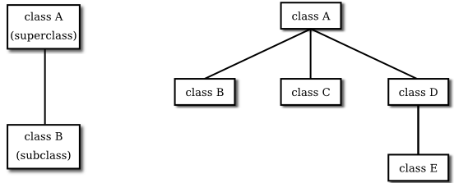

2. What syntax is used to get one class to inherit data and behavior from another class?

1. The word ‘Extends’ is used to inherit data from another class.

3. How does the keyword super work with constructors?

1. The word super calls the constructor in the superclass.

4. How does the keyword super work with methods other than constructors?

1. Super can be used to call other methods in the super class.

5. What is the role of the visibility modifier protected in a class hierarchy?

1. The visibility modifier restricts the ability to modify variables in a given class, to the subclass.

6. Find the error in the following code and suggest a remedy for the problem:

Shape s = new Wheel();

s.setSpokes (5);

1. The error is that setSpokes is not in the shape interface (which s is in), so s must be cast to a wheel, before setSpokes can be called by s.